Cairo University

Faculty of Engineering

Systems and Biomedical Engineering Department

Second Semester - 2023/2024

Computer Vision - Task 01

**Team #02**

Nouran Mahmoud

Nada Omran

Mohammed Sami

Kareem Salah

Youssef Ahmed

Table of Contents

Additive Noise 4

Overview 4

Additive noise within images is considered to be random fluctuations in pixel values that overlay the underlying image. This phenomenon can arise from various sources, including transmission errors, sensor imperfections, electronic disturbances, or environmental factors. In digital image processing, additive noise can be used to test various processing techniques, especially filters. Within ImageAlchemy, we provide users with the feature of adding three different types of additive noise: uniform, Gaussian, and salt and pepper noise. However, it's important to note that there are other types of additional variants of additive noise beyond these three options. 4

Uniform Noise 4

Gaussian Noise 5

Implementation 6

Observations 6

Filters 7

Overview 7

Implementation 7

Observations 8

Applying the filter on clear images (without noise): 8

Applying the filter on noisy images 10

Filtrating noisy images results 10

Edge Detection 13

Overview 13

Sobel Operator 14

Prewitt Operator 16

Roberts Operator 17

Local and Global Thresholding 18

Laplacian Operator 19

Canny Edge Detector 20

Local and Global Thresholding 22

Brief 22

Global Thresholding 24

Local Thresholding 24

Observations 25

Histogram Equalization 25

Brief 25

The difference between colored images and greyscale images. 26

General Histogram Equalization (GHE) Algorithm 26

The results 27

Image Normalization 29

Simple Rescale Normalization 30

Zero Mean and Unit Variance Normalization 30

Min-Max Scaling Normalization 30

Alpha-Beta Normalization 30

The Results 31

Frequency Filters 31

Brief 31

Low Pass Filtering implementation 31

Results 33

Observation 34

High Pass Filtering implementation 34

Results 35

Observation 36

Hybrid Images 36

Brief 36

Results 37

Observation 38

# Additive Noise

### Overview

# A person wearing a hat Description automatically generatedAdditive noise within images is considered to be random fluctuations in pixel values that overlay the underlying image. This phenomenon can arise from various sources, including transmission errors, sensor imperfections, electronic disturbances, or environmental factors. In digital image processing, additive noise can be used to test various processing techniques, especially filters. Within ImageAlchemy, we provide users with the feature of adding three different types of additive noise: uniform, Gaussian, and salt and pepper noise. However, it's important to note that there are other types of additional variants of additive noise beyond these three options.

Figure 1: Uniform Noise with range [0:0.5]

## Uniform Noise

This type of noise is commonly caused by poor lighting or transmission channel error. In this type, the intensity values of the noise pixels are uniformly distributed within a specified range. That means that the probability of any intensity value within this specified range is constant.

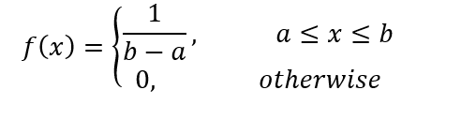

## Gaussian Noise

It is commonly caused by thermal vibrations within the camera sensor, electronic interference, and environmental factors. It is considered a significant challenge for some tasks, such as object recognition and image analysis. This type of noise follows a Gaussian/normal distribution where most values are concentrated around a central value (mean) and fewer values are farther away. The severity of this noise is related to the standard deviation (sigma) of the Gaussian distribution. A higher standard deviation leads to larger variations in pixel intensity, and vice versa.

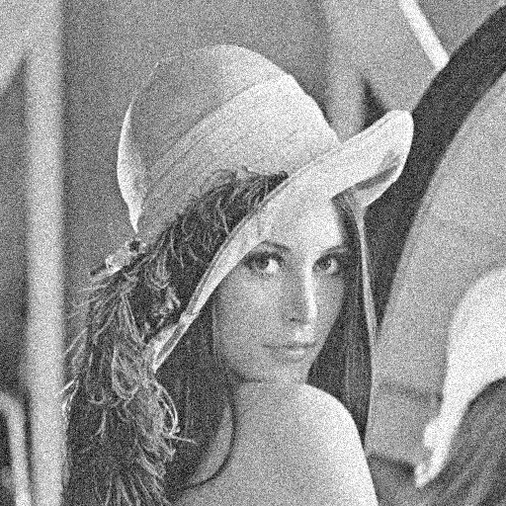

Figure 2: Gaussian Noise with 0.25 mean and 0.25 standard deviation

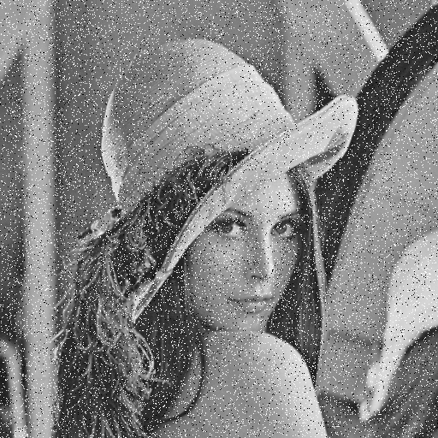

Figure 3: Salt and Pepper Noise: 0.02 salt with 0.07 pepper

**Salt and Pepper Noise**

This type arises mainly from malfunctioning imaging devices or transmission channel errors. It is so-called because it appears as bright and dark pixels in an image, like grains of salt and pepper sprinkled on a surface.

## Implementation

In our app, we used numpy, which is a Python library for numerical computing, to generate the random pixel values of the noise, and we then added them to the image that the user imported. Depending on the type of noise we are generating, we are using different functions of Numpy. So to generate uniform noise or Gaussian noise, we use *random. Uniform* or random.normal, respectively, with different parameters. To generate uniform noise, we only need to specify two parameters, which are the lower and upper limits, and then generate the noise image with the same size as the image to which we are adding the noise. In Gaussian noise, we are controlling the spread of the noise using the standard deviation and the location of the central value using the mean. For salt and pepper noise, we are generating a uniform noise within the range of 0 and 1. And then looping on these generated intensity values, setting the low-intensity values below a specified threshold to 0 ("black") and the high-intensity values above a specified threshold to 255 ("white").

## Observations

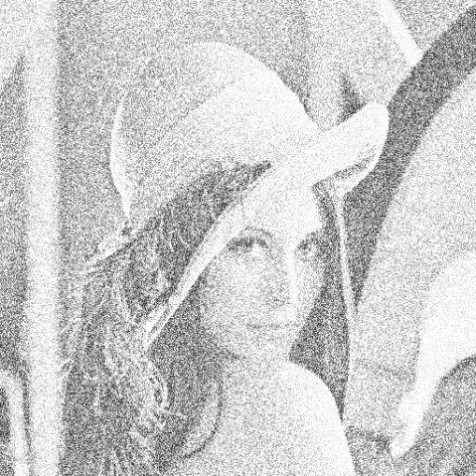(Figure 4) Increasing the range of uniform dist-ribution, the lower and upper limits, in the case of uniform noise leads to greater variability in the noise component in the image. In other words, the pixel values vary more widely, which may destroy a lot of the image details.

Figure 4, Uniform Noise with range [0:2]

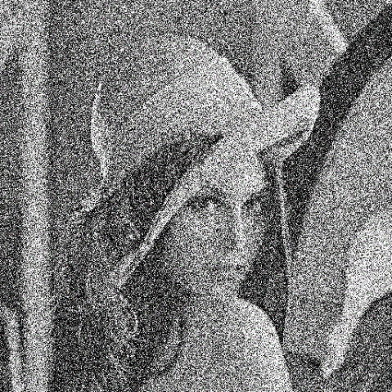

Figure 5, Gaussian Noise with 0 mean and standard deviation of 1

(Figure 5) A higher standard deviation in the Gaussian noise increases the spread of the noise along the image. So like the uniform noise, this leads to greater variability in the noise pixel values and image destruction.

# Filters

### Overview

Filters are image-processing techniques that are meant to transform or enhance images in some sort of way in a lot of paradigms, such as edge detection, blurring or sharpening, feature extraction, segmentation, noise reduction, etc. Within **ImageAlchemy**, we offer the feature of adding three different types of filters to the imported image: mean filter, median filter, and Gaussian filter.

## Implementation

General Approach:

1. In making filters, a filter kernel is first defined. A kernel is a small matrix of numbers that represents the weights of the filter. And kernels vary in size and value depending on the filter type or operation we need to perform.
2. This kernel should be combined with the image. But before this, we need to pad the image from the four sides to make sure that the output image has the same dimensions as the input image after convolution. There are multiple methods or modes of padding, such as padding with constant values, padding with edge values, padding with the mean or median of all or part of the vector along each axis, etc.
3. Convolution operation: the filter kernel is then convolved with the padded image. Convolution involves sliding the kernel over the entire image and computing the dot product between the kernel and the corresponding region of the image at each position. This is repeated for every pixel in the image.

For the mean filter, the kernel weights are all set to 1. This kernel is then convolved with the image, where each pixel in the kernel is multiplied by the corresponding pixel in the image. The resulting values are summed together and divided by the total number of pixels in the kernel to compute the average. This output is the filtered pixel in the new image.

For the median filter, the process goes the same as for the mean filter, but instead of computing the mean, we compute the median of the kernel values, which is the middle number in a sorted list of numbers (the kernel in our case).

For the Gaussian filter, the kernel is calculated by multiplying two Gaussian functions, one in each dimension:



In the step of convolution, we calculate the weighted sum of the pixel values within the window, where each pixel value is multiplied by the corresponding weight from the Gaussian filter kernel.

## Observations

### Applying the filter on clear images (without noise):

If we applied mean and median filters to the same image with the same kernel size, we found that the image along with the edges and all fine details is smoothed and more blurred in the case of the mean filter. However, we found the median filter succeeded in smoothing the image while preserving the details and sharp transitions of the image.

|  |  |
| --- | --- |
| A person wearing a hat  Description automatically generatedFigure 6, Median Filter with kernel size 7x7 | A person wearing a hat  Description automatically generatedFigure 7, Mean Filter with kernel size 7x7 |

In the case of the Gaussian filter, all the images and edges are softened, but still, the edges are a bit clearer than the mean filter. Upon increasing the standard deviation (sigma) value, the Gaussian distribution becomes flatter, so the blurring increases.

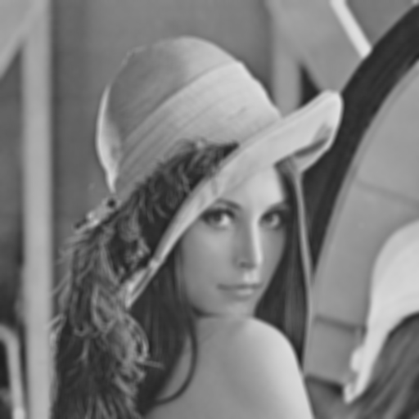

Figure 8, Gaussian Filter with kernel size 7x7 and standard deviation of 5.8

### Applying the filter on noisy images

Upon applying the filters to noisy images generated by our application, we found that the mean filter is more efficient in reducing uniform and Gaussian noise. While the median filter is perfect for eliminating salt and pepper noise, The Gaussian filter is suitable for reducing the Gaussian noise.

|  |  |  |  |
| --- | --- | --- | --- |
|  | **Most effective** | **Medium effect** | **Least effective** |
| **Mean Filter** | Uniform | Gaussian | Salt and Pepper |
| **Median Filter** | Salt and Pepper | Uniform | Gaussian |
| **Gaussian Filter** | Uniform | Gaussian | Salt and Pepper |

#### Filtrating noisy images results

**Mean Filter:**

|  |  |
| --- | --- |
| Figure 9, Mean Filter 5x5 vs. Uniform Noise | Figure 10, Mean Filter 5x5 vs. Gaussian Noise |
| A person wearing a hat  Description automatically generated  Figure 11, Mean Filter 5x5 vs. Salt & Pepper Noise | |

**Median Filter:**

|  |  |
| --- | --- |
|   Figure 12, Median Filter 5x5 vs. Uniform Noise |   Figure 13, Median Filter 5x5 vs. Gaussian Noise |
| Figure 14, Median Filter 5x5 vs. Salt & Pepper Noise | |

**Gaussian Filter:**

|  |  |
| --- | --- |
| Figure 15, Gaussian Filter 5x5 with sigma of 4 vs. Uniform Noise | Figure 16, Gaussian Filter 5x5 with sigma of 4 vs. Gaussian Noise |
| Figure 17, Gaussian Filter 5x5 with sigma of 4 vs. Salt and Pepper Noise | |

# Edge Detection

## Overview

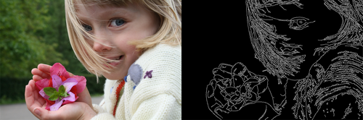

Edge detection is a fundamental task in image processing and computer vision that aims to identify the boundaries between different objects or regions within an image. Detecting edges is crucial for various applications such as object recognition, image segmentation and feature extraction. Several techniques have been developed to accomplish this task, each with its own advantages and limitations, but the overall idea is hovering around computing the derivatives, either first-order or second-order, in the form of 2D convolution in different directions using some predefined kernels.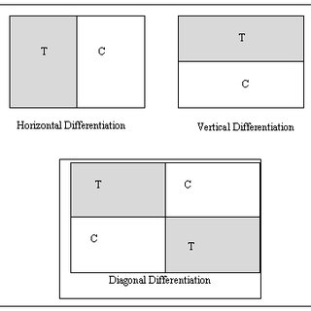

The derivatives, or we can say the finite differences in a discrete medium, can be computed in one of three directions, either horizontal, vertical or diagonal. The detector can combine between these different ways. It may also include some optimization techniques for better results.

In our program, we have considered **five** different types of edge detection algorithms, namely **Sobel, Prewitt, Roberts, Laplacian and Canny**.In the subsequent sections we are going to consider each detection method separately while going through its advantages and limitations beside sample output for each for comparison. Then, we are going to discuss some implementation considerations that have contributed to speeding up the computational time, therefore enhancing the user experience.

## Sobel Operator

The Sobel operator is a gradient-based edge detection method that computes the first derivative of the image intensity. It utilizes a pair of **3x3 or 5x5** kernels to approximate the gradient in the horizontal and vertical directions separately. By convolving these kernels with the image, the Sobel operator calcualtes the gradient magnitude and direction at each pixel, emphasizing regions of rapid intensity changes that correspond to edges in this case. In general, the Sobel operator provides respectful and humble results, particularly in the presence of noise. In addition this operator itself is used as a sub-stage in the Canny edge detection algorithm.

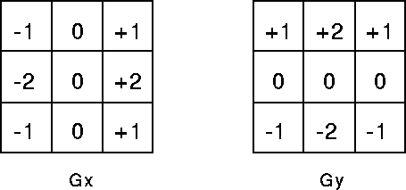

As mentioned before, we have provided two different sizes of Sobel operators **(3x3 & 5x5)**. The difference between them resides in the balance between noise robustness and edge localization, as well as computational resources available. For **3x3** operator, this smaller kernel size makes the computation faster and requires less memory. Moreover, it provides a more localized response, which can be advantageous for detecting fine details and sharp edges. However, it may be more sensitive to noise compared to larger kernels. On the other hand, the **5x5** operator offers more smoothing effect due to its larger size, which in turn helps in reducing the localized noise. Furthermore, it provides a broader response, which can be beneficial for edges with gradual intensity changes. This all comes at the expense of increasing the computational complexity and memory requirements.

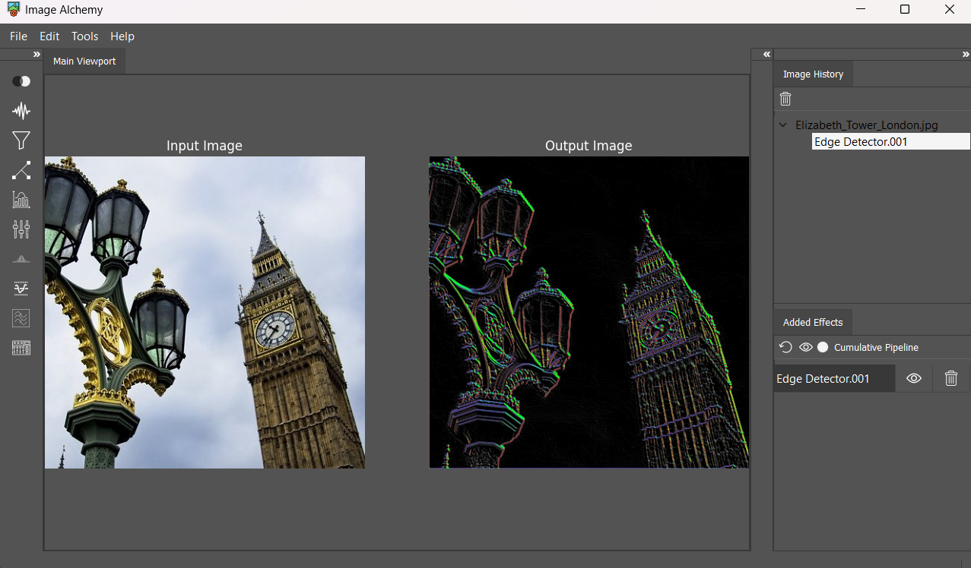

(Figure no.02: The output of **5x5** Sobel operator)

(Figure no.02: The output of **5x5** Sobel operator)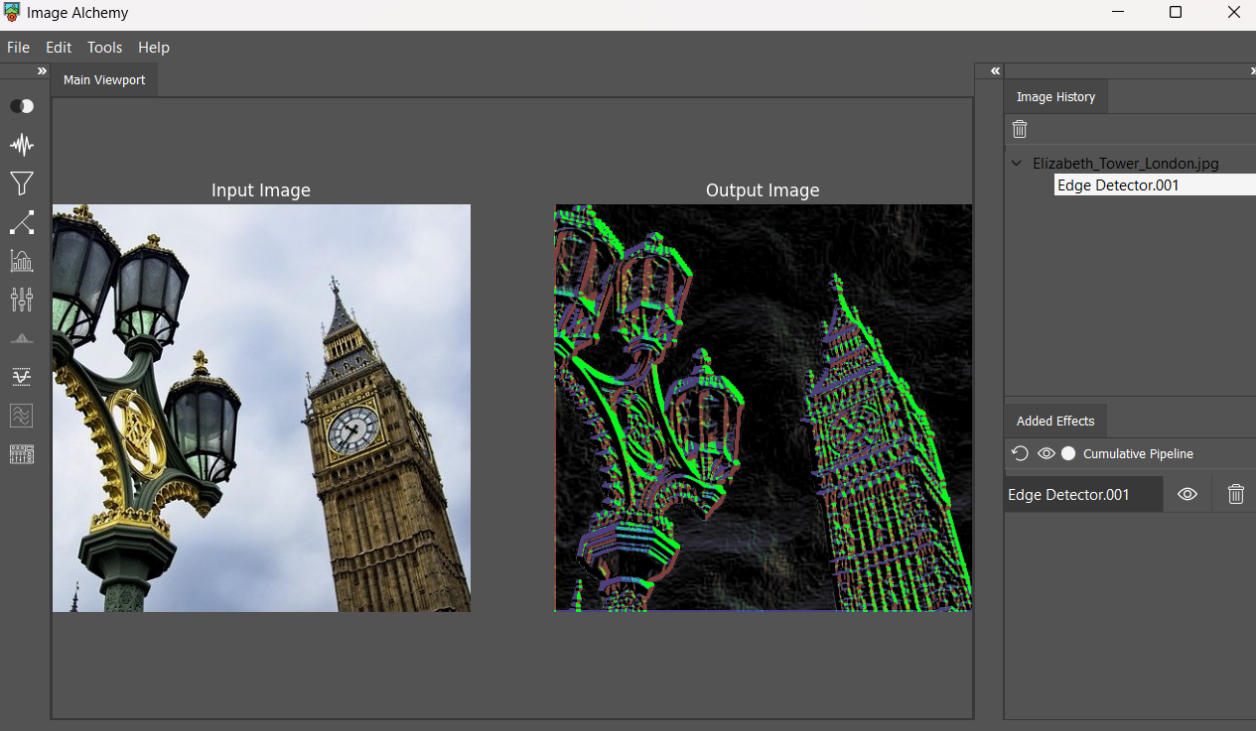

Figure 18: The output of 3x3 Sobel operator

(Figure no.01: The output of **3x3** Sobel operator )

Note the difference between the two above operators, and how they comply with the comparison we have conducted between 3x3 and 5x5 operators. The **3x3** operator could detect the **fine details** in the image, while the **5x5** could detect the edges of **broader gradual change** in intensity like that case with sky clouds.

**The colors in the above output samples signify the direction of gradient.** Edges of the same color have the same direction of gradient.

## Prewitt Operator

Similar to the Sobel operator, the Prewitt operator is another gradient-based edge detection method that computes the first derivative of the image intensity. It employs a pair of 3x3 kernels to estimate the horizontal and vertical gradients independently. By combining these gradients, the Prewitt operator identifies edge pixels on abrupt changes in intensity along both directions. While less commonly used than the sobel operator, the prewitt operator offers comparable performance in edge detection tasks.

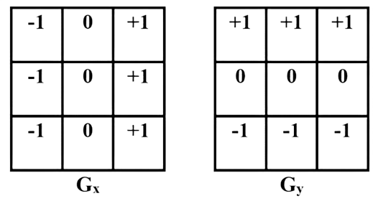

The primary difference between the 3x3 prewitt and Sobel operator lies in the uniform distribution of weights in the Prewitt kernel versus the emphasis on central pixel weight in the Sobel kernel, which in turn impact the edge detection performance and computational complexity. For that reason, the Sobel operator outperforms the Prewitt operator slightly.

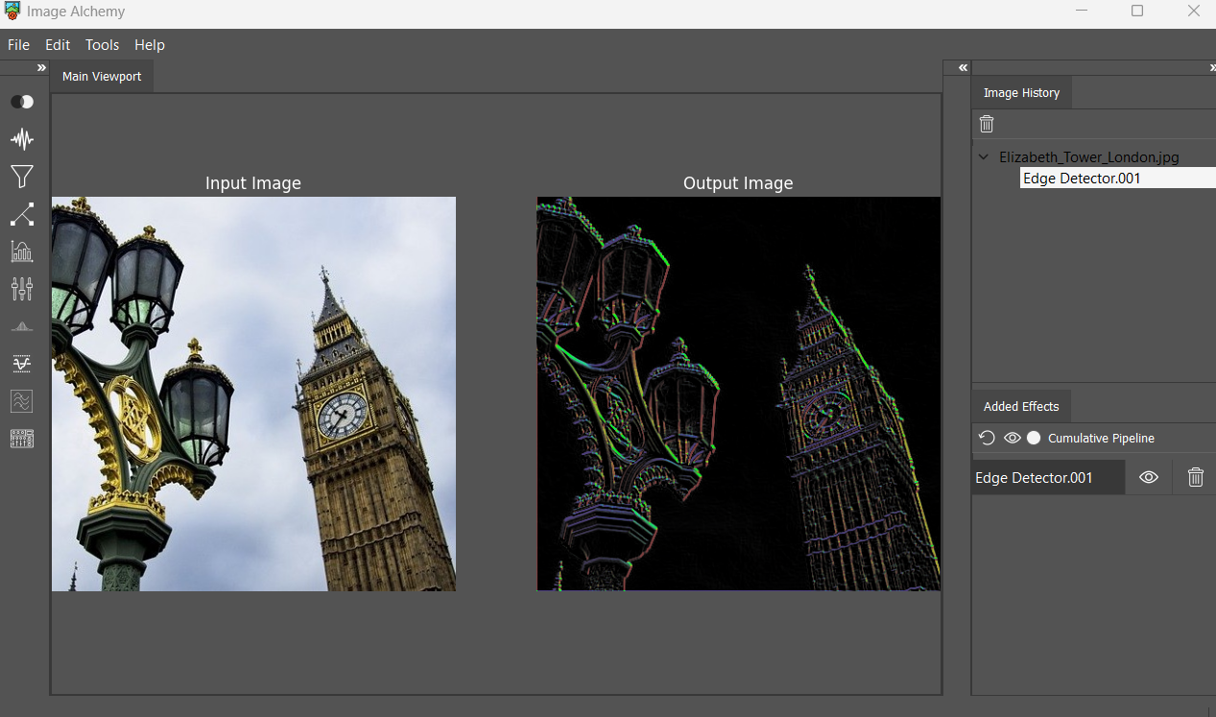

Figure 19: The output of 3x3 Prewitt operator

As we can see, there is no significant difference between its output and that of the Sobel operator of the same size.

## Roberts Operator

The Roberts operator is one of the earliest edge detection techniques, utilizing a pair of 2x2 kernels to compute the gradient of the image intensity diagonal-wise. It emphasizes edges with high intensity gradients by convolving the image with these kernels. Despite its simplicity, the Roberts operator is less robust to noise and may produce thicker edges compared to more advanced methods. However, its effectiveness can vary depending on the image characteristics.

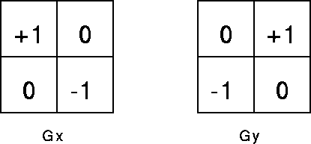

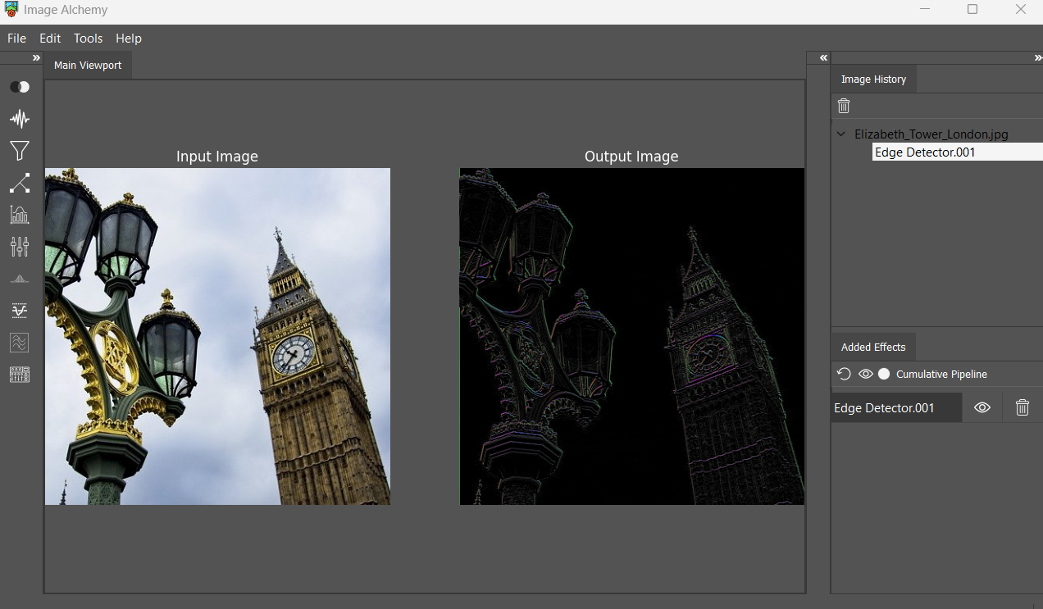

Figure 20: The output of Roberts operator with fairly clear image

# 

# 

# 

# 

# 

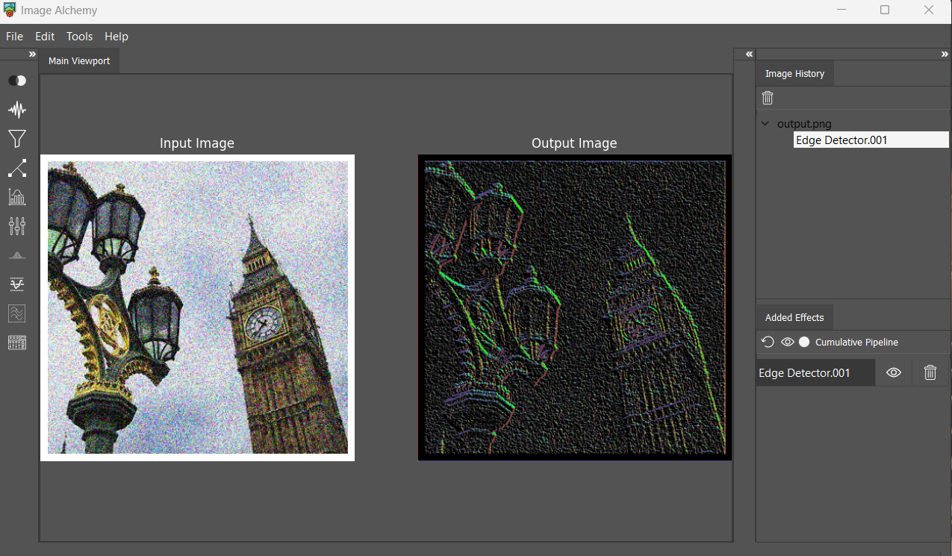

Figure 21 shows how the operator is sensitive to noise.

# 

# Local and Global Thresholding

## Laplacian Operator

The Laplacian operator is a second-order derivative-based edge detection approach that highlights regions of rapid intensity changes in an image. The Laplacian operator detects edges and corners by emphasizing areas with significant intensity variations (rate of change of the range of change). However, it is highly sensitive to noise and tends to produce thick edges with low contrast.

|  |  |  |
| --- | --- | --- |
| 1 | 4 | 1 |
| 4 | -20 | 4 |
| 1 | 4 | 1 |

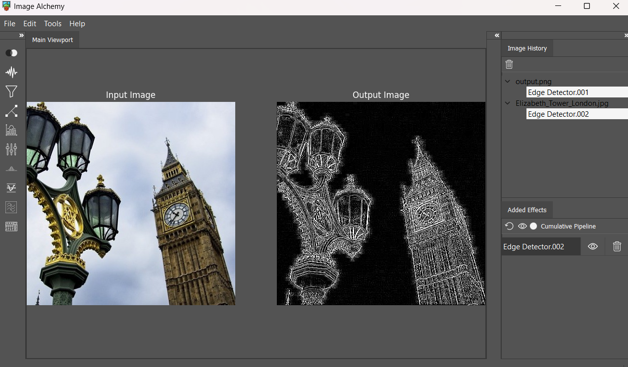

Figure 22: The output of laplacian before smoothing out the image

As shown in the above figure, the output of the laplacian operator is very noisy, since it detects edges using second-order derivatives, making it so sensitive to variations.

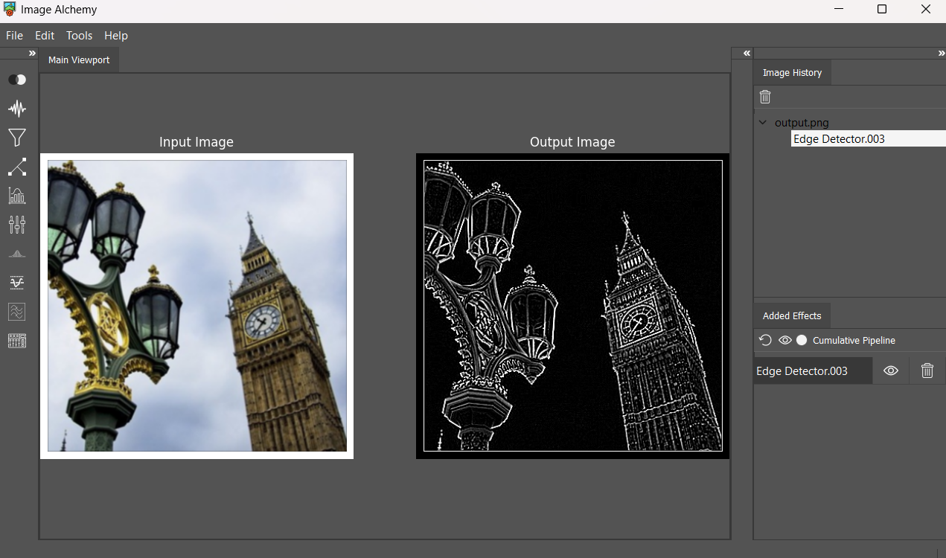

Figure 23: The output of laplacian after smoothing out the image

## 

## 

After applying the gaussian filter, then applying the laplacian operator we could come out with cleaner edges, since we could suppress such significant variations.

## Canny Edge Detector

The Canny Edge detector is a multi-stage algorithm that incorporates the following steps:

1. **Gaussian Smoothing**: Applying Gaussian blurring to input image to reduce noise and small variations.This step is **optional** to the user, where in some cases applying filters would be redundant computations.
2. **Gradient Computation**: Calculating the gradient magnitude and direction using first derivatives (**Sobel 3x3 detector has been used**) to highlight areas of rapid intensity changes, which are potential edges. (Just Candidates) 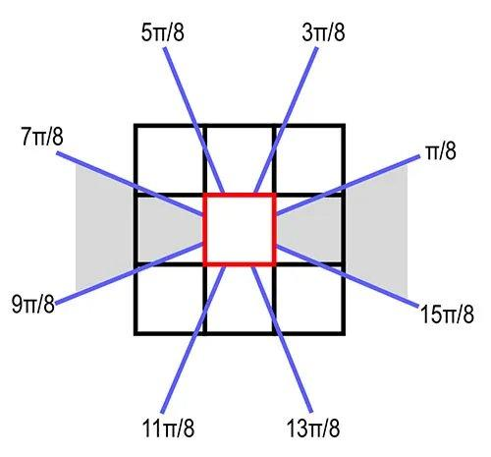
3. **Non-Maximum Suppression**: Adopting such an algorithm to thinning the detected edges by suppressing non-maximum gradient values along the direction of the gradient. This step helps to ensure that only the local maxima contributes to the final edge map.
4. **Double Thresholding**: Adopting such technique of classification to classify pixels as strong, weak, or non-edges based on their gradient magnitudes. Pixels with gradient magnitude above the high threshold are considered strong edges, while those below the low threshold are considered non-edges. Pixels with gradient in-between are labeled as weak edges that we want to check for being strong candidates or just noise. So, for these weak edges we conduct what is known as connectivity analysis using a technique called Hysteresis. 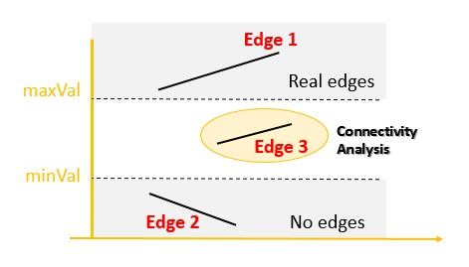
5. **Hysteresis (Connectivity Analysis):** In this algorithm we iterate over each weak detected edge and check the adjacent 8 pixels if any of them is strong, then we set that edge as a strong edge, otherwise it’s non-edge.

# Local and Global Thresholding

## Brief

Thresholding is a fundamental technique in image processing and computer vision that separates objects from the background based on pixel intensity. Local thresholding and global thresholding are two common methods used for this purpose. In Global thresholding we select a single threshold value to classify all pixels in an image as either object or background, while in Local thresholding we divide the image into blocks and calculate a threshold for each block by taking the average for the block pixel's value, this allows for more flexibility in handling variations in lighting and background intensity within the image, therefore global thresholding is suitable for images with uniform lighting conditions and a clear separation between the object.

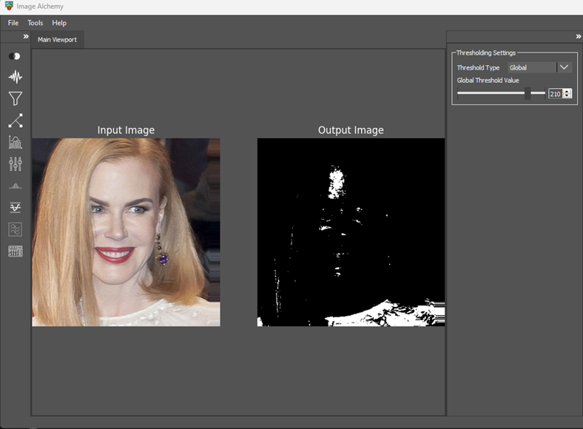

Figure 24: High Global Threshold Effect

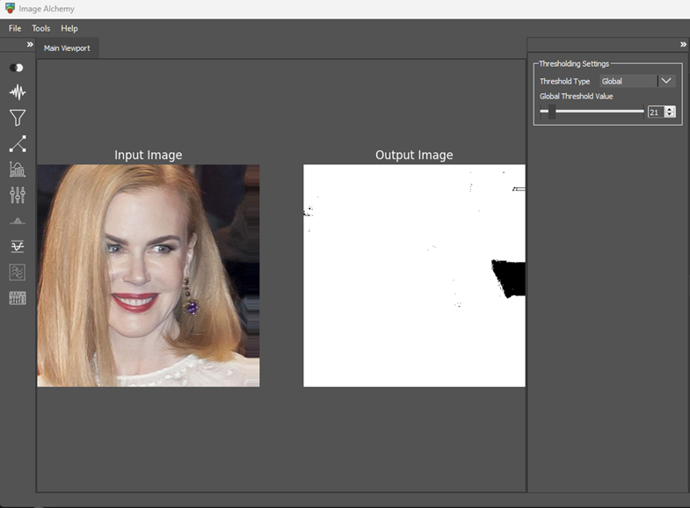

Figure 25: Low Global Threshold Effect

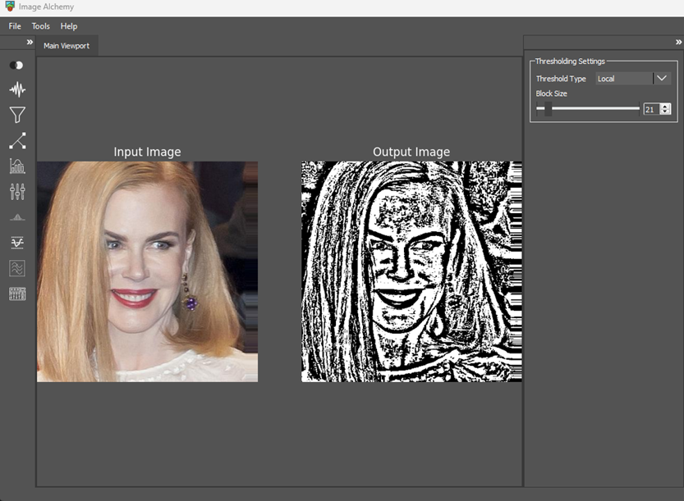

Figure 26: Normal Kernel Size

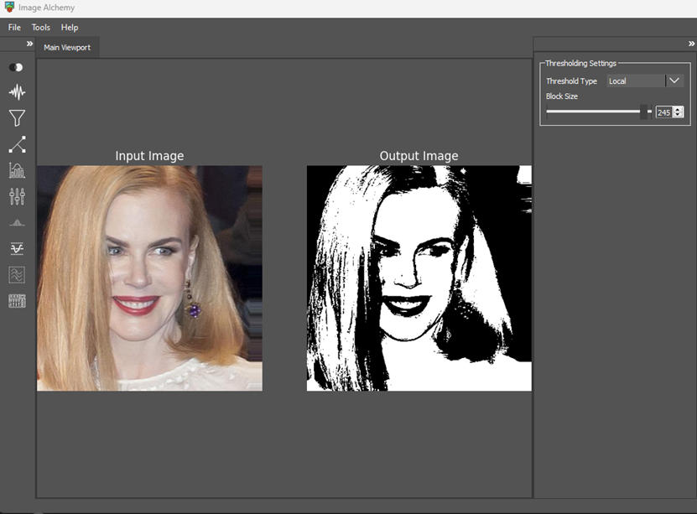

Figure 27: Large Kernel Size (Smoothed)

## Global Thresholding

In global thresholding, a single threshold value, denoted as T, is applied to all pixels in the image. The formula to binarize an image using global thresholding is:

Where the Binary image (x, y) is the binary image after thresholding, and image(x, y) is the pixel value at location (x, y) in the original image.

## Local Thresholding

In local thresholding, different threshold values are applied to different regions of the image. The used approach is to calculate the local threshold for each pixel based on the mean intensity of its neighborhood. Let it be denoted as Tmean:



Where the Binary image (x, y) is the binary image after thresholding, and image(x, y) is the pixel value at location (x, y) in the original image.

## Observations

We will now discuss the effects of changing parameters such as the global threshold value and the kernel size in local thresholding.

making the kernel size very large may lead to over-smoothing of the image and loss of finer details, while making the global threshold value very high or very low will make most of the image either black or white and we will be unable to identify the object.

# Histogram Equalization

## Brief

Histogram equalization is a technique used in digital image processing to enhance the contrast of an image. When plotting the histogram of an image, for instance, a greyscale image, the histogram represents the distribution of the grey levels. If the intensity levels are skewed to the right (high-intensity values), the image will be too bright, and the details in the bright parts will be lost. Conversely, if the intensity levels are skewed to the left (low-intensity levels), the image will be too dark, and the details in these parts will be lost. The goal of Equalization is to spread the histogram bins/columns across the grey levels to achieve an equal distribution and better contrast. This has many applications like enhancing X-ray images.

## The difference between colored images and greyscale images.

Histogram Equalization can be applied to both 3D color images and 2D grayscale images. If the image is a 2D grayscale image, the equalization is applied to the gray levels histogram. However, if the image is a 3D RGB image, it’s first converted to the CIELAB color space, and the equalization is applied to the L channel. This is because, in the CIELAB domain, the L channel represents the intensity levels in the image, while the a* and b* channels represent color combinations.

## General Histogram Equalization (GHE) Algorithm

This Algorithm is applied on a specific channel.

Firstly: Calculate the histogram of the channel. This creates a frequency array of each intensity level. Intensity levels range between 0 and 255.

Then Calculating the cumulative summation of this frequency array. One of the properties of a flat/equalized histogram is a linearized CDF function. So we calculate the Cumulative Histogram, and normalize it to have a maximum value equal to the maximum value of the histogram array. Then we apply linear interpolation for the normalized CDF array to get the linearly mapped intensity levels. Then we assign these values to the equalized channel.

## The results

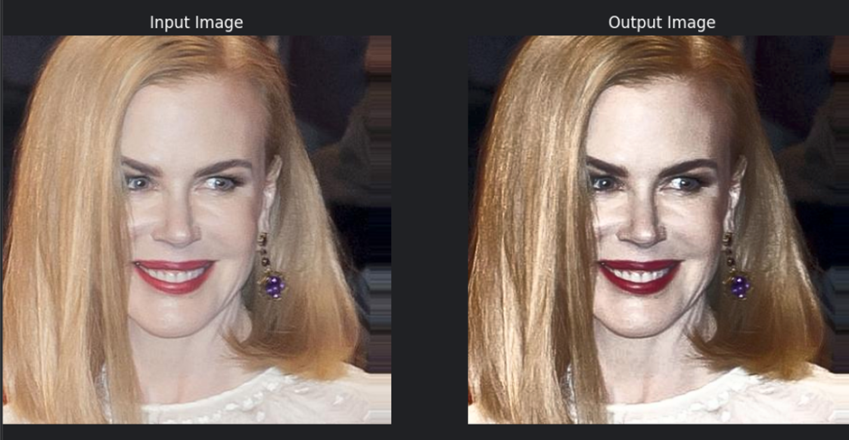

Figure 28: The result of GHE algorithm on a colored image

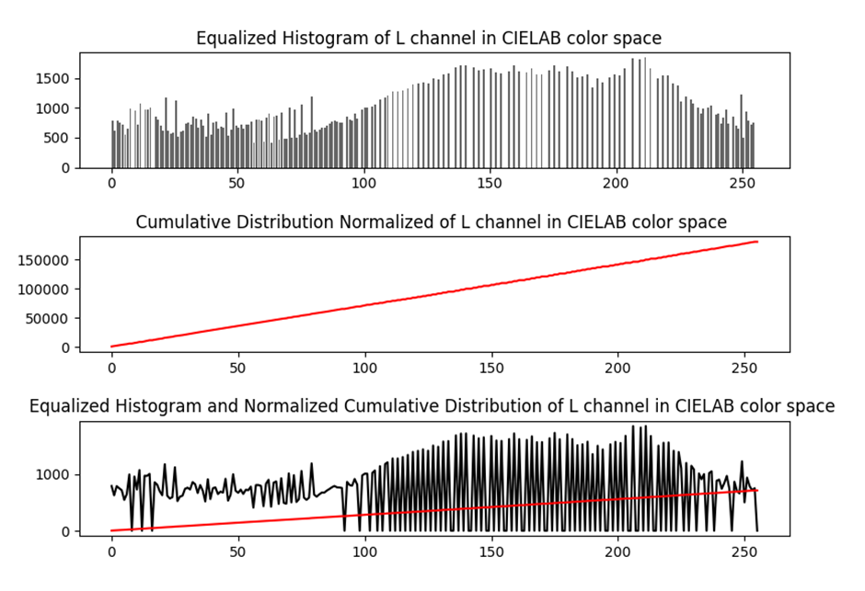

Figure 29: A figure containing 3 plots: 1- The Histogram of the Equalized L channel for the above image. 2- The Cumulative Summation of the Histogram of the Equalized L channel. 3- A continuous plot of the Histogram of the Equalized L channel and the Cumulative S

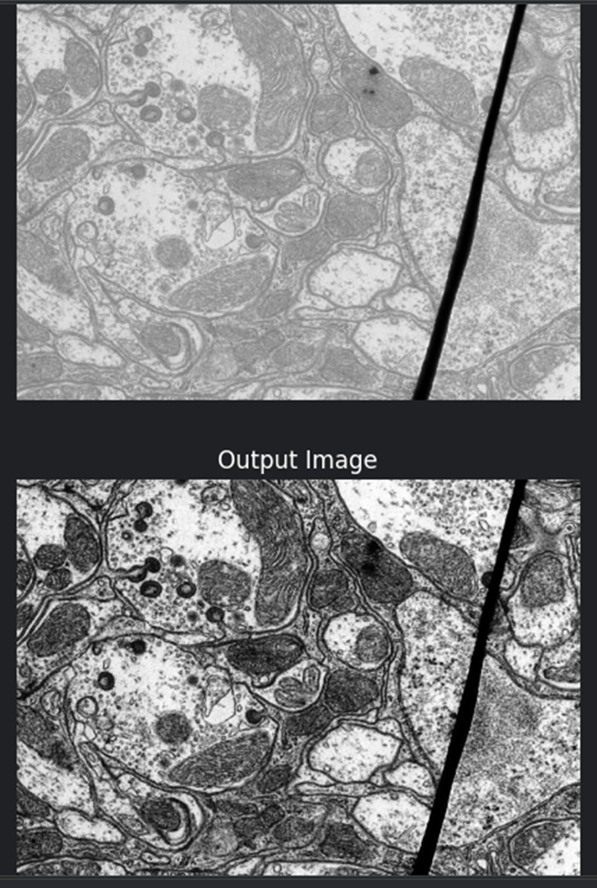

Figure 30: The result of GHE algorithm on a grayscale image

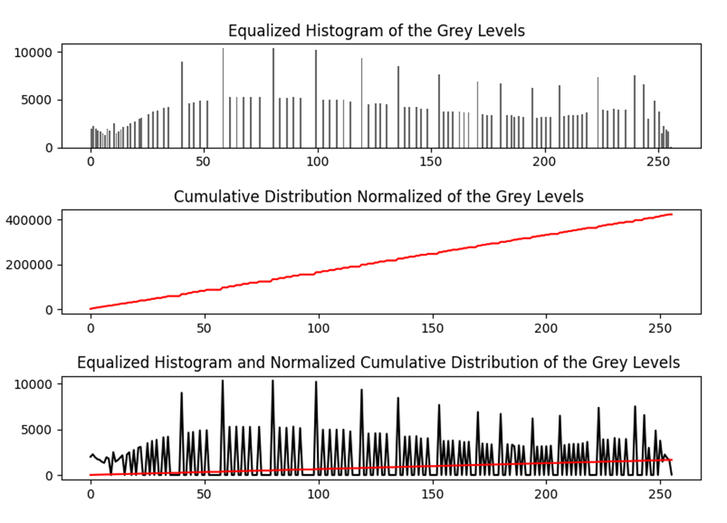

Figure 31: A figure containing 3 plots: 1- The Histogram of the Equalized grey levels histogram for the above image. 2- The Cumulative Summation of the Histogram of the Equalized grey levels histogram. 3- A continuous plot of the Histogram of the Equalized grey levels histogram.

# Image Normalization

Image normalization is a common preprocessing step in image processing and computer vision. It aims to standardize the range of pixel intensity values, which can vary across different images. Normalization improves the performance of many algorithms by ensuring that features extracted from the image have the same scale. The application has 4 methods for normalization.

## Simple Rescale Normalization

This is the most straightforward method of normalization. It involves rescaling the pixel intensity values to the range [0, 1]. This is done by dividing each pixel value by the maximum possible value (255 for an 8-bit image). The result is an image with pixel intensities that are proportional to the original but confined to a smaller range.

## Zero Mean and Unit Variance Normalization

This method ensures that the pixel intensity distribution of the image has a mean of 0 and a standard deviation of 1. It is achieved by subtracting the mean and dividing by the standard deviation of the pixel intensities. This type of normalization is often used when the algorithm assumes that the input data is normally distributed, or when it’s sensitive to the scale of the input data.

## Min-Max Scaling Normalization

Min-Max scaling scales the pixel intensity distribution of the image to the range [0, 1]. It is done by subtracting the minimum pixel value and dividing by the range of pixel values (maximum-minimum). This type of normalization is often used when the algorithm assumes that the input data lies within a specific range. This normalization is used in Machine Learning applications for features normalization. pixels values typically range between 0-255, so this normalization typically provides a similar output to the Simple Rescale Normalization.

## Alpha-Beta Normalization

This method scales the pixel intensity distribution of the image to a specified range [alpha, beta]. It is a more generalized form of Min-Max scaling where the range is user-specified instead of being fixed at [0, 1]. This can be useful when the algorithm requires input data to be within a specific range.

## The Results

The result is a normalized grayscale version of the image.

# Frequency Filters

## Brief

Frequency Domain filters are essential tools in Image Processing used to remove some frequency components from the images. Frequency Domain Filtering is performed through extracting the frequency content of the image using Fourier’s Transform, then multiplying it with a filter and applying Inverse Fourier’s Transform. Low Pass and High Pass Filters are the most basic Frequency Domain Filters. Low pass filter removes the high frequency components to smooth the images while High Pass filter removes the low frequency components to sharpen the images.

## Low Pass Filtering implementation

1. Apply Fourier’s Transform to transform the image to frequency domain

F(u,v)= 𝑓{f(x,y)}

Where:

* F(u,v) is the image in the frequency domain
* f(x,y) is the image in the spatial domain

1. Shift the zero frequency to the center of the spectrum
2. Create a filtering mask of the same size of the image with initial values of zero
3. Assign the desired values to each index in the filter as follows:

$H(u,v)=1$ $if D(u,v)$ $≤$ $D_{O}$

$H(u,v)=0$ $if D(u,v)$ $> D_{O}$

Where:

* H(u,v) is the filter
* D(u,v) is the distance between the current index and the middle index in the array, and it is calculated as follows:

$D(u,v)=$ ${({(u- \frac{R}{2})}^{2}+{(v-\frac{C}{2})}^{2})}^{0.5}$

* R is the number of rows of the filter, and C is the number of columns
* Do is the cut off frequency that the user enters, the cut off frequency is the radius of the circle whose values are assigned to one in the filter

1. Multiply the filter with the image in the frequency domain

$$G(u,v)=F(u,v)⋅H(u,v)$$

Where:

* G(u,v) is the filtered image in the frequency domain

1. Apply inverse Fourier’s Transform to get the filtered image in spatial domain

$$g(x,y)= f^{-1}\{G(u,v)\}$$

Where:

* g(x,y) is the filtered image in the spatial domain

## Results

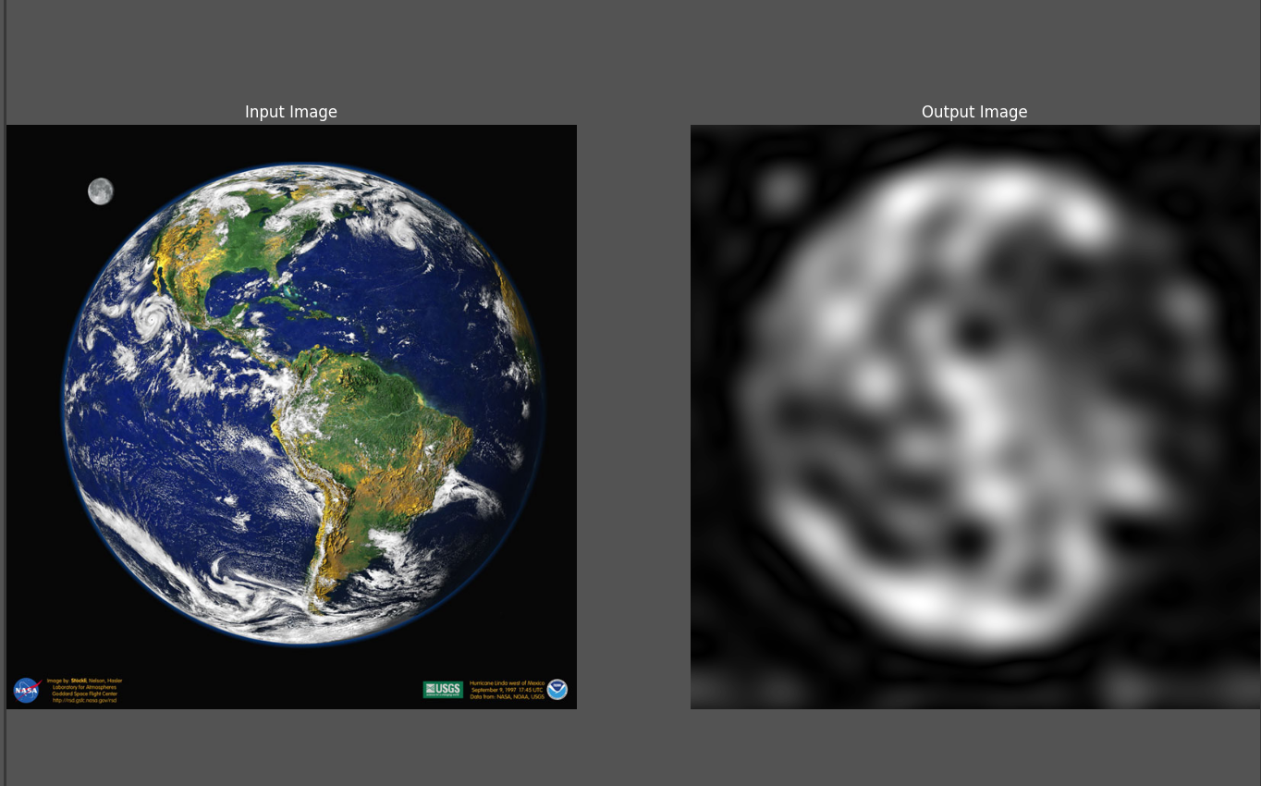

Figure 32: Low Pass filtered image with cut off frequency 10

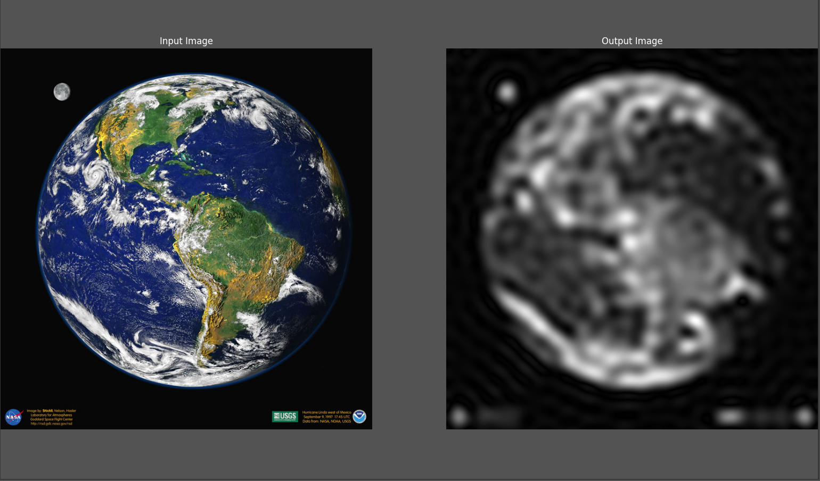

Figure 33: Low Pass filtered image with cut off frequency 20

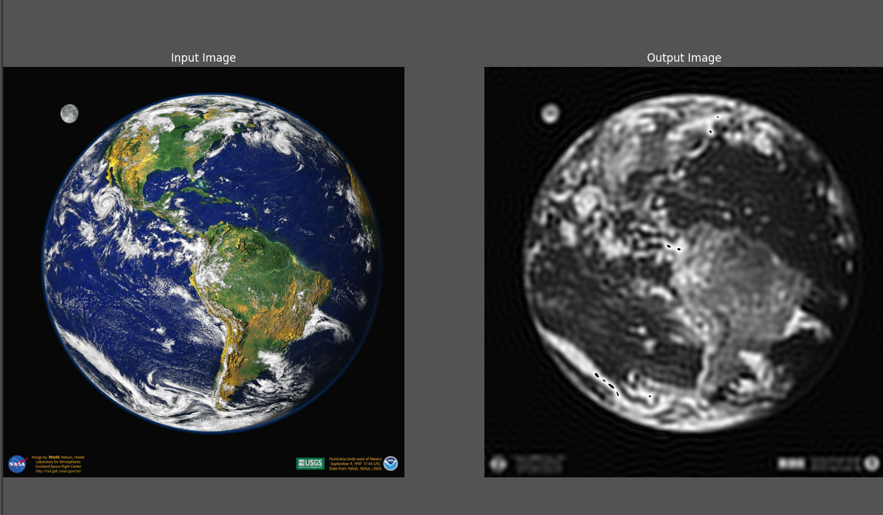

Figure 34: Low Pass filtered image with cut off frequency 50

## Observation

In a low pass filter as the cut off frequency decreases, the frequency content that will be removed gets bigger, so the smoothing effect increases, and the filtered image loses most of the details of the original image

On the other hand, large cut off frequency means that the circle of frequencies that won't be zeroed gets bigger, so the filtered image looks more like the original

## High Pass Filtering implementation

A high pass filter can be implemented as follows:

1. Create a low pass filter as illustrated above
2. High Pass Filter= 1 – Low Pass Filter, by that all the ones in the low pass filter are converted to zero and all the zeros are converted to ones
3. Multiply the filter with the image in the frequency domain then transform it to spatial domain using inverse Fourier’s Transform as we did in the low pass

## Results

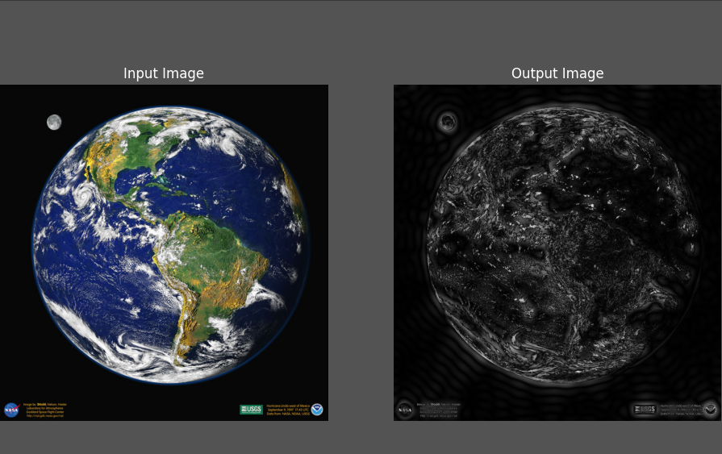

Figure 35: High Pass filtered image with cut off frequency 20

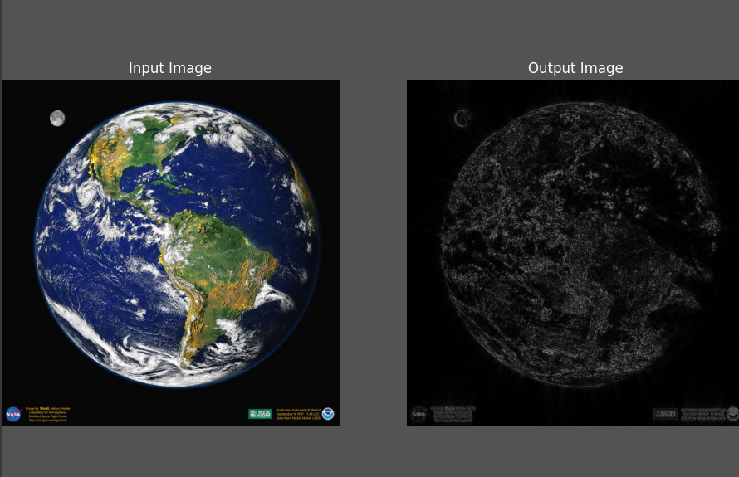

Figure 36: High Pass filtered image with cut off frequency 80

## Observation

In a High Pass Filter, as the cut off frequency increases, more frequency content is being removed, so less edges appears in the filtered image

While as the cut off frequency decreases the size of the circle that will be zeroed gets smaller, so larger frequency content is being taken, so the filtered image contains more edges and looks more like the original image

# Hybrid Images

## Brief

Hybrid Images are a type of visual illusion. They are created through summing a low pass filtered image with a high pass filtered image, the resulting image appears different as the viewing distance changes. When you get too close to the image you see the high pass filtered image more clearly, while when you get too far you see the low pass filtered image more clearly.

**Hybrid image implementation**

The function takes two images

1. If the images sizes are not the same, it resizes the second image to match the first image size using our resize function (discussed in the following paragraph)
2. Perform low pass filtering (as illustrated in the low pass filtering implementation) on the image that the user choose to take its low frequency content and high pass filtering (as illustrated in the high pass filtering implementation) on the other image
3. Sum the two filtered images

As for the resize function, it takes the image to be resized and the new dimensions we want to achieve

1. Calculate the scaling factor for each dimension
2. Create an array of zeros of the new size we want to achieve
3. Assign values for the pixels of the new array through performing nearest neighbor interpolation

Nearest Neighbor Interpolation:

1. Each pixel in the new array is mapped to get its original location in the original image, using the calculated scaling factor
2. The four nearest pixels to the mapped position are determined by rounding the floating values up and down to obtain the nearest integer pixel coordinates.
3. Measure the distance between each of the four pixels with the mapped pixel
4. Assign the value of the nearest pixel to the current pixel in the new image

## Results

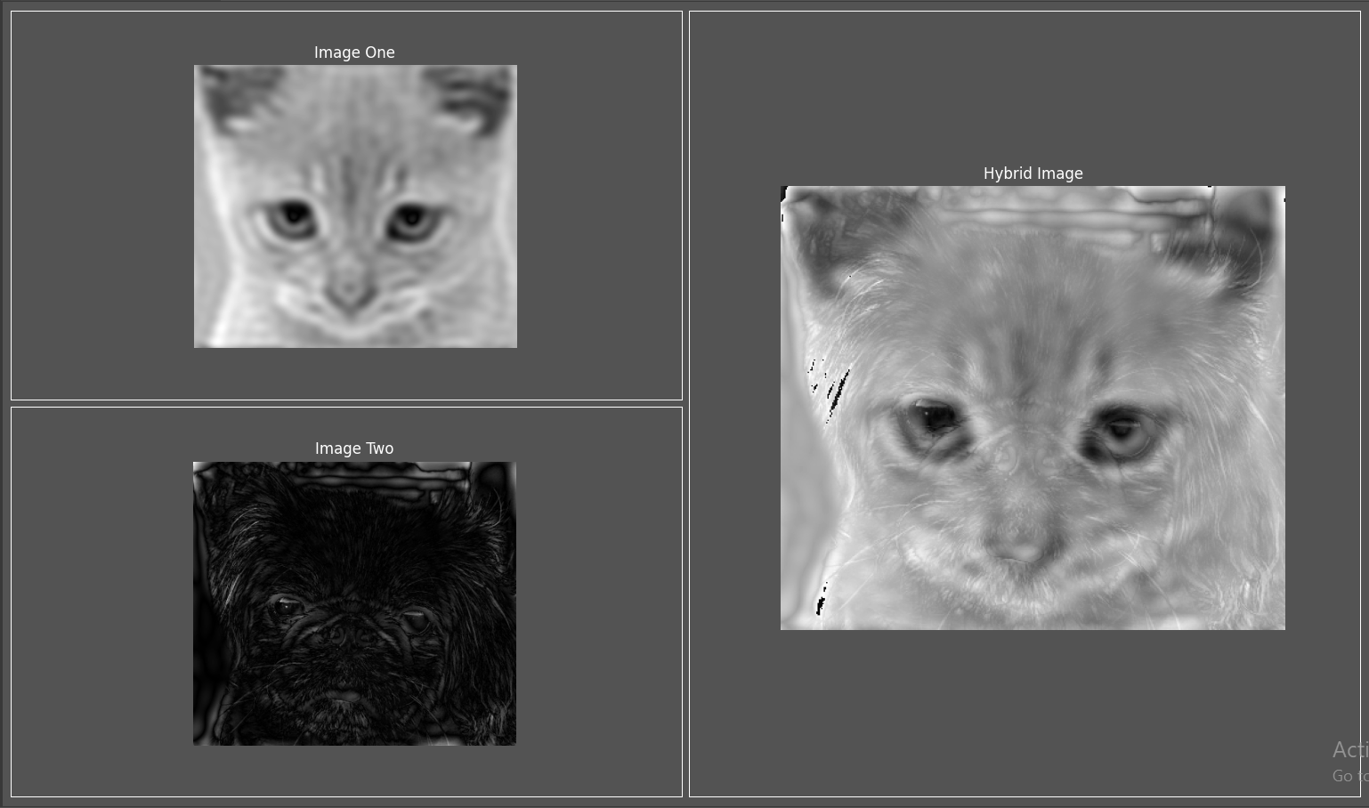

Figure 37: Hybrid Image

(Figure 19: Hybrid Image)

## Observation

When you get too close to the hybrid image you see the high pass filtered image more clearly, while when you get too far you see the low pass filtered image more clearly. You may need to adjust the cut off frequency of the filters based on the two input images to achieve better results.